GET System Architecture

Overview
The Groundwater Evaluation Tool (GET) solution is a web-based interface to the USGS’s Modflow groundwater modeling tool. The goal of GET is to remove the intricacies of working with Modflow by offering simple and intuitive ways to provide data inputs, and powerful visualization tools to interpret the data output.
GET will use cloud technology to isolate Modflow versions and models to ensure several scenarios for multiple users can be run concurrently in a scalable manner.

Architecture

Components
The proposed system will be hosted on Microsoft’s Azure cloud infrastructure, while being designed in a flexible manner to be hosted on-site in a traditional Windows based environment if needed.
The following components will make up the GET solution:
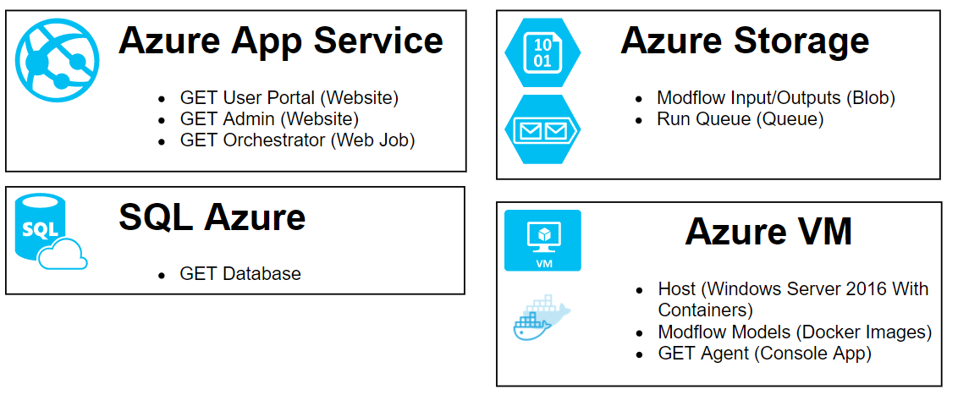
- GET Portal
  - Web portal for GET users
- GET Admin
  - Administrative web portal for Olsson users to manage customers, feature access, etc.
- GET Orchestrator
  - Web job managing queued runs and containers
- GET Database
  - Transactional database for the GET system
- Run Queue
  - Queue of Modflow runs that need to be executed
- Modflow Input/Output Storage
  - Blob storage containers which will contain raw Modflow inputs and parsed run results
- GET Agent
  - Console application running in each container responsible for fetching input files and parsing Modflow run results
- Docker Host
  - Windows Server 2016 with Containers VM hosting a Docker image per model available to the system
- Modflow Models
  - Docker images containing all the necessary model files (except for the user inputs) and version of Modflow to execute a customer’s model.

Component Interactions

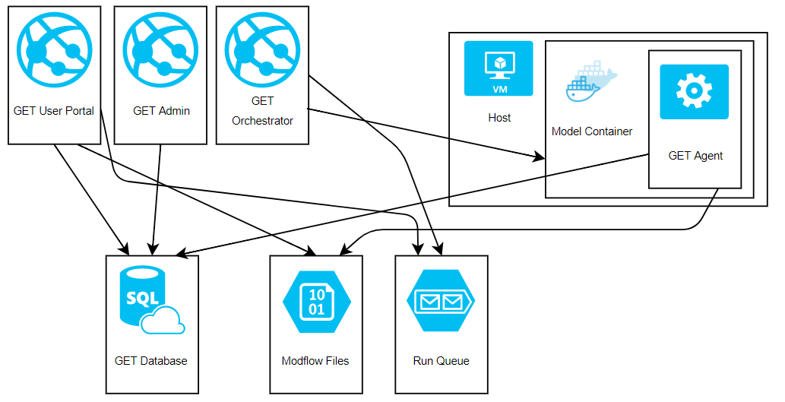

Modflow Workflow
The main use case for the GET system is a user logging in to run a new model, and later seeing it’s results. Given the long running nature of Modflow models, a queuing system will be used to manage model runs. The proposed system will work as following:
- User creates a run in the GET Portal that will be saved to the GET Database
- The portal will translate the user inputs into a Modflow input file and write it to BLOB Storage
- The portal will add an item to the Run Queue, indicating there’s a model that needs to be ran.
- The GET Orchestrator will watch for new items in the queue.
- Once an item is found, it will create a container from the Docker image with the appropriate model files for the specific run.
- The GET Agent in the container will run when the container is started, and fetch the input files from BLOB storage.
- The GET Agent will translate input file into a WEL file
- The GET Agent will execute and monitor Modflow
- Once the Modflow process is complete, the GET Agent will interpret the results
- GET Agent will save the results to BLOB Storage.
- When the results are parsed and interpreted, the GET Agent will update the database, indicating the run is completed.
- User logs in to see the run’s result.
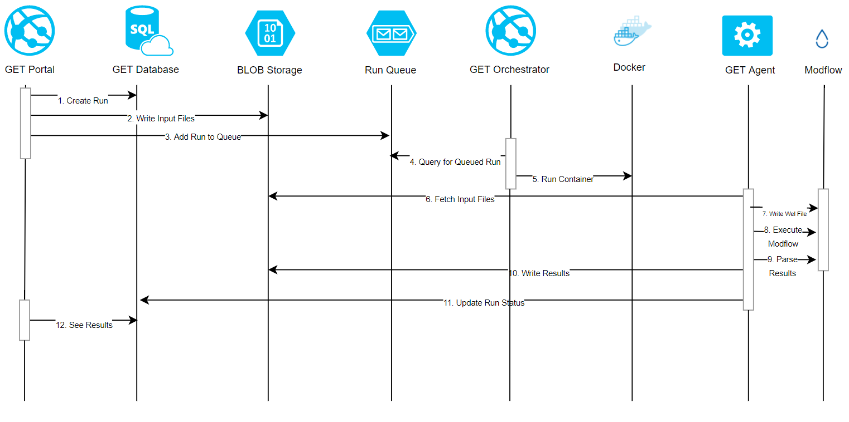

Estimated Hosting Costs
Estimated costs for hosting on Microsoft Azure are as following.
Feature | Tier | Cost
App Service | S2 – 2 Core, 3.5 GB RAM | $147/Mo
SQL Database | S2 – 50 DTUs, 250 GB | $75/Mo
Blob & Queue Storage | 500 GB | $10/Mo
Windows 2016 Server VM | A2 v2 – 2 Core, 4 GB RAM or  A4 v2– 4 Core, 8 GB RAM | $101-$212/Mo
 | Total: | $330-$440/Mo

Note that we also create a QA/Staging environment with lower tier levels for testing purposes.
Depending on what SLAs are established with GET customers, geo-redundant features may be necessary but probably not necessary given Azure’s current uptime records.
Costs do not include DNS registration, SSL certificates, or marketing website.
Once live, we can work with Olsson Associates IT department to determine data backup strategies and monitoring. Standard level App Services and Databases include daily backups stored for 30 days but different frequencies and terms can be configured.

